# Supporting Information for:

## XXXX XXXX1, XXXX XXX2, XXXX XXXXXX3

1 School of Environmental and Geographical Sciences, Shanghai Normal University, Shanghai, 200234, China

2 School of

3 Faculty of

Corresponding author, Email:

**Number of pages: , Number of tables: , Number of figures:**

**Contents**

1 Current state of wastewater and sludge treatment in China sludge growth, laws, and policies in China S4

2 Methodology S5

2.1 The W2IO model S5

2.2 The W2IO table and other data S8

2.3 Scenario analysis S15

2.4 Sensitivity analysis S16

3 Results S17

3.1 Wastewater and sludge footprint by final demand categories S17

3.2 Direct discharge versus footprint S17

3.3 Sensitivity analysis S17

3.4 Transboundary impacts S21

References S21

**List of Figures**

Figure S1 Wastewater and sludge footprint by final demand categories ................S17

Figure S2 Direct discharge versus W2F of the largest 40 sectors...........................S17

**List of Tables**

Table S1 Framework of the W2IO table....................................................................S6

Table S2 Production sector classification: Xiamen IO table................................... S8

Table S3 The allocation matrix $S$ of waste/wastewater to treatment processes....S12

Table S4 The W2IO table of Xiamen based on the framework in Table 1............ S13

Table S5 COD and wastewater discharge..............................................................S14

Table S6 Data on food (diet, toilet discharge, and carbon content) ......................S15

Table S7 Sensitivity elasticity of pre-consumption W2F and SF to input and waste generation coefficients...........................................................................S18

Table S8 Sensitivity elasticity of post-consumption W2F and SF with respect to key parameters..............................................................................................S20

Table S9 Wastewater and sludge embodied in trade..............................................S21

## 1 The current state of wastewater and sludge treatment in China

## 2 Methodology

### 2.1 Data Preparation

#### 2.1.1 Sludge data calculation

Sludge data in China are collected by the Ministry of Housing and Urban-Rural Development of the People’s Republic of China (MHURD). MHURD publishes *Urban Construction Yearbook* every year which has yearly sludge production in each city. However, some data from this *Yearbook* has an obvious bias. To eliminate the bias and inconsistency, we collected the information from *Urban Drainage Yearbook* which contains the yearly treatment data of all the wastewater treatment plants (WWTPs) in China. We used the name of WWTP to find its location (coordinate) through Baidu map. Identifying the city where the WWTP locates and summing all the sludge data of each WWTP in that city. Finally, we used our calculation to substitute the biased data in the *Urban Construction Yearbook* (Figure S1).

Sludge production highly correlate to the flow of wastewater treatment (Figure S2). Based on this correlation, we calculated the sludge production of each wastewater treatment plants in China with the following equation:

$Ds=365×F×s$

Where *Ds* represents dry sludge, *F* is the flow of wastewater treatments and *s* is the conversion coefficients which were obtained from *Urban Drainage Statistical Yearbook* (Table S1)*.*

We grouped sludge production data by prefecture level, calculating the sum of sludge production in a city. Compared our calculation with *Urban Construction Yearbook,* fixed its inconsistency.

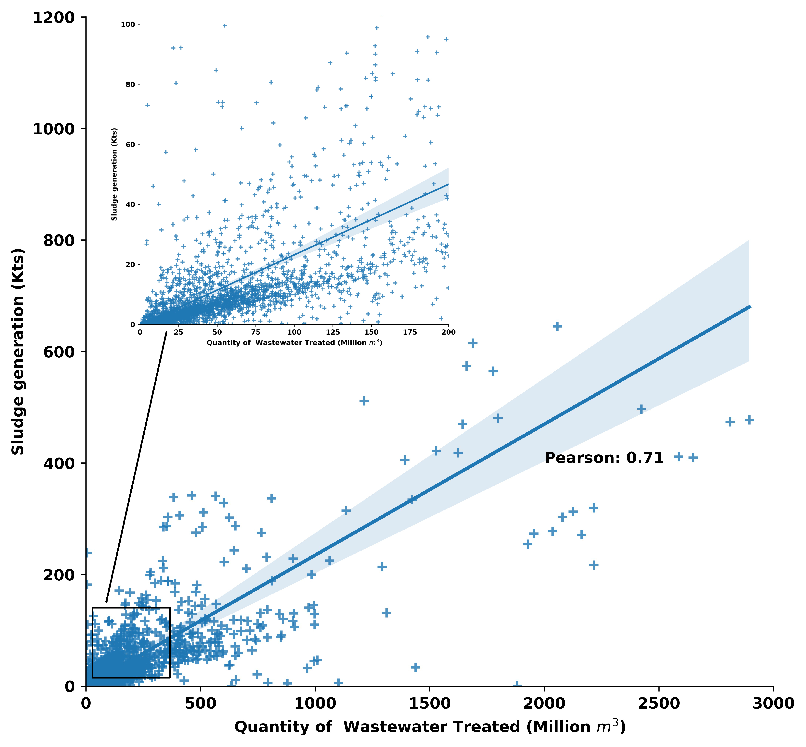

**Figure S2.** Correlation between sludge generation and the quantity of wastewater treated

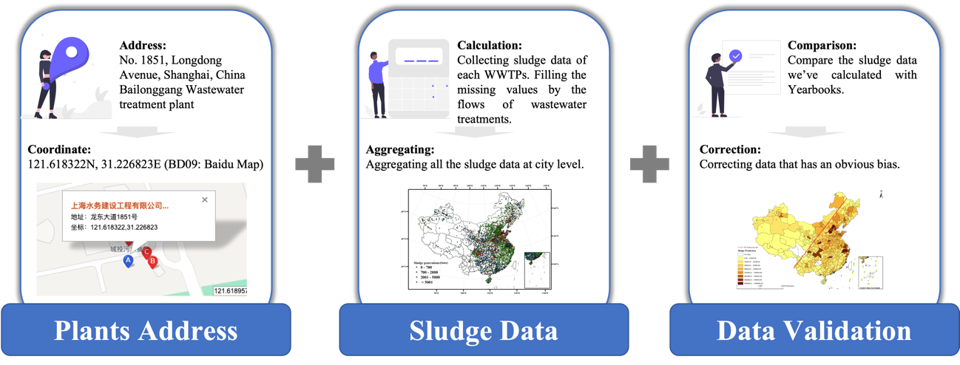

**Figure S1.** The workflow of collecting sludge data

### Sludge Projection

|  |  |
| --- | --- |
| **Province** | **s (t/10 Kts)** |
| Beijing | 7.31 |
| Tianjin | 5.95 |
| Hebei | 8.26 |
| Shanxi | 7.51 |
| Inner Mongolia | 6.98 |
| Liaoning | 4.61 |
| Jilin | 4.13 |
| Heilongjiang | 5.60 |
| Shanghai | 4.56 |
| Jiangsu | 6.43 |
| Zhejiang | 9.95 |
| Anhui | 4.61 |
| Fujian | 4.01 |
| Jiangxi | 3.07 |
| Shandong | 7.85 |
| Henan | 6.55 |
| Hubei | 4.65 |
| Hunan | 3.29 |
| Guangdong | 4 |
| Guangxi | 3.37 |
| Hainan | 3.48 |
| Chongqing | 6.04 |
| Sichuan | 5.31 |
| Guizhou | 3.56 |
| Yunnan | 4.77 |
| Tibet | 2.27 |
| Shaanxi | 7.83 |
| Gansu | 9.92 |
| Qinghai | 6.22 |
| Ningxia | 7.55 |
| Xinjiang | 7.91 |

#### 2.2.1 Production sector classification

The IO table in Xiamen contains 139 sectors (Table S2), with a water supply and production aggregated with wastewater treatment.

### Scenario analysis

### Sensitivity analysis

## References

CCNPS (Compilation Committee for National Pollution Survey). Household Discharge Coefficient and Use Instructions. China Environmental Science Press. 2011.(in Chinese)

GSC (General Office of the State Council). Pilot Work Plan for the Construction of Wasteless Cities. 2018. In Chinese.

Heijungs R and Lenzen M. Error propagation methods for LCA - a comparison. International Journal of Life Cycle Assessment. 2014, 19(7): 1445-1461.